To update your Group Record
Log in to Beacon https://www.u3abeacon.org.uk
From the home page Click on Groups
Click on your group from the list.
Choose Members from the horizontal list across the top
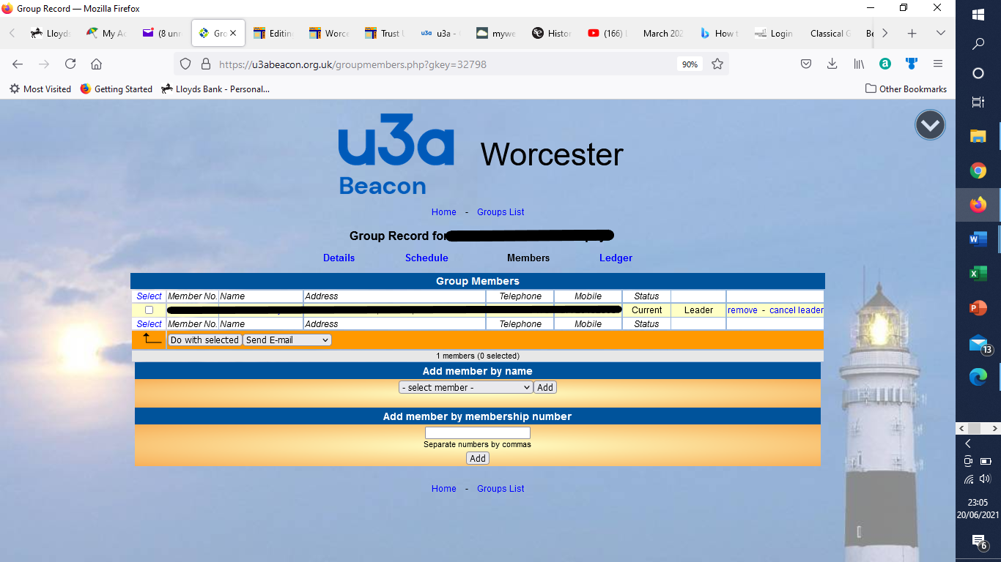
Add members using select member from the drop-down list and click Add
To delete members click on Remove at the side of their name.
To make a member a leader select make leader, to remove the leader role select cancel leader. (Groups can have multiple leaders if required.)
Inform the Beacon Web Advisor of changes in recorded leaders

