To print a register
Log in to Beacon https://www.u3abeacon.org.uk
From the home page Click on Groups
Click on your group from the list.
Choose Members from the horizontal list across the top
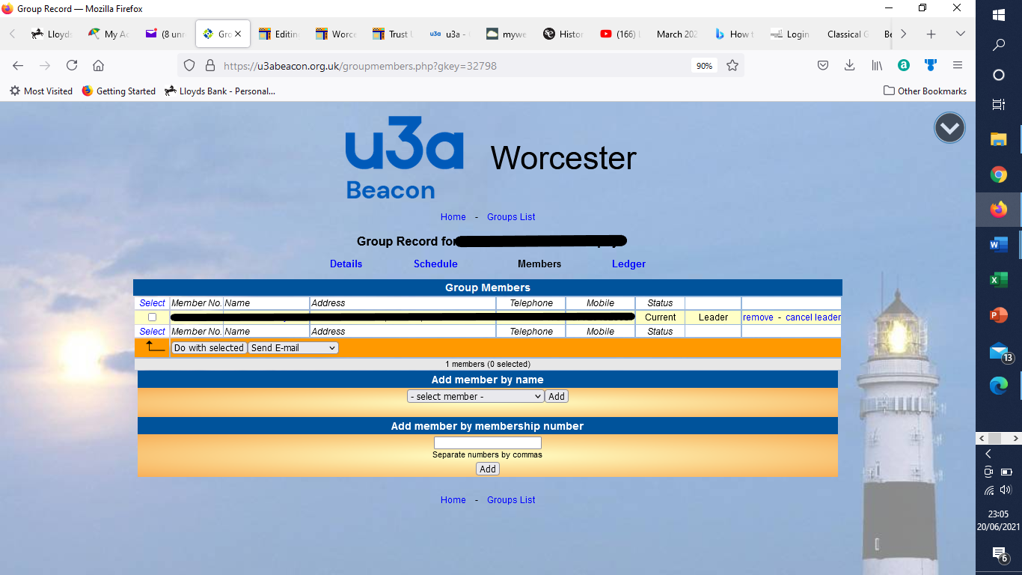
Select all
Select download excel from drop down box next to ‘do with selected’
Press ‘do with selected’
Select fields to be included in download, select ‘download’
Enable editing on your downloaded Excel file
In page Layout choose Landscape orientation
Add the dates of your sessions across the top
In Page Layout tick Gridlines view and Gridlines print
File Print

