To email your group list
Log in to Beacon https://www.u3abeacon.org.uk
From the home page Click on Groups
Click on your group from the list.
Choose Members from the horizontal list across the top
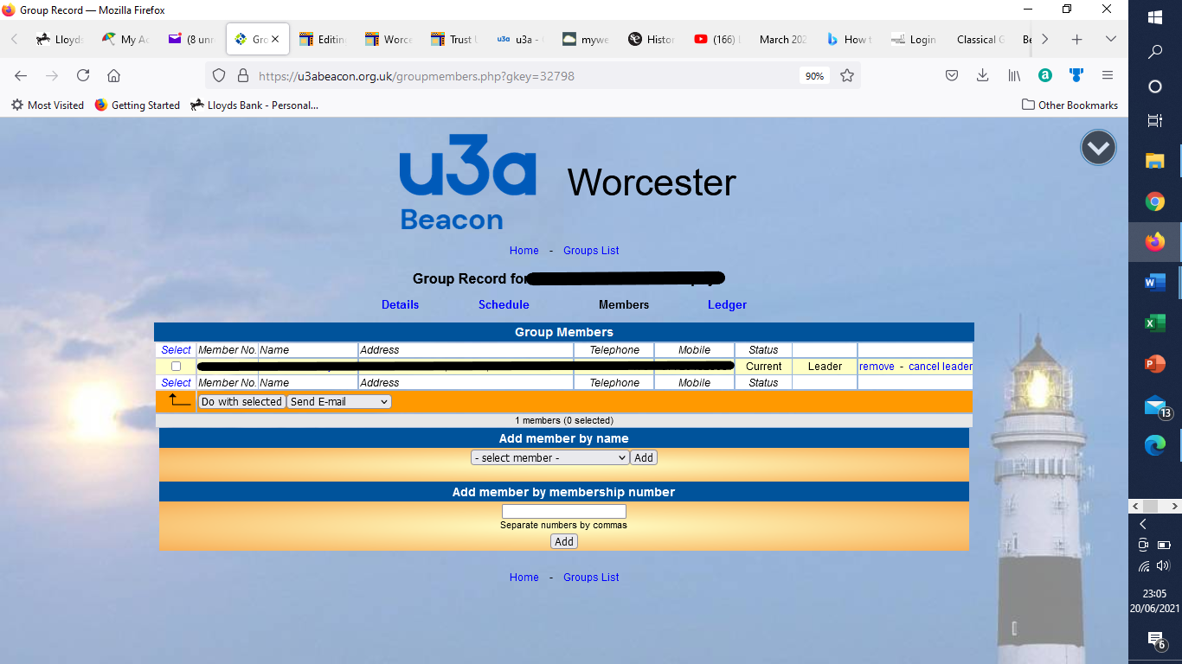

Select who you want to email. (or click select on top or bottom left and choose E-mail only)
Select send email from drop down box next to ‘do with selected’
Then press ‘do with selected’

