To contact a committee member
Log in to Beacon https://www.u3abeacon.org.uk
From the Home page, click on U3A officers (under Misc).
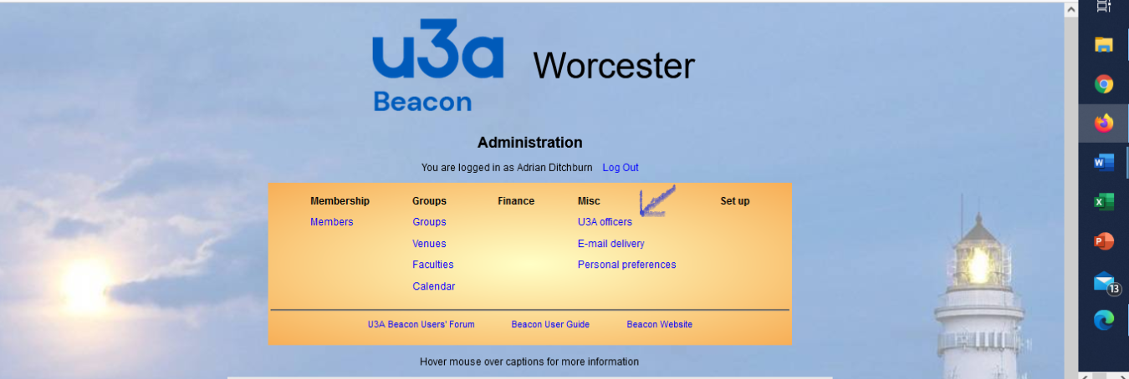
Select who you want to message and select send email from drop down box next to ‘do with selected’
Then press ‘do with selected’

